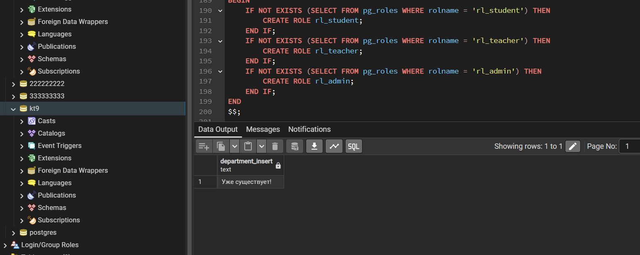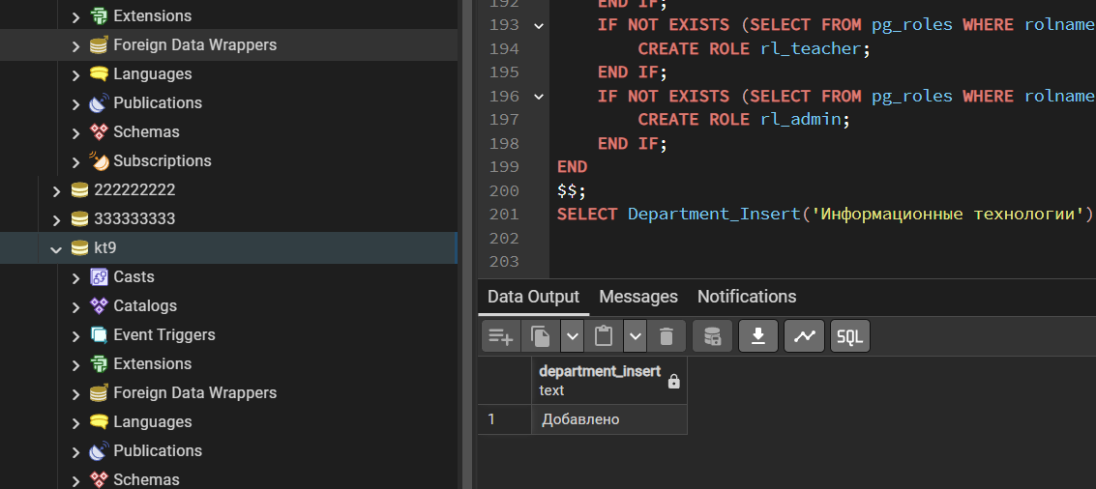
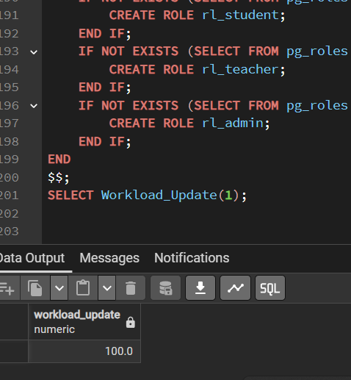
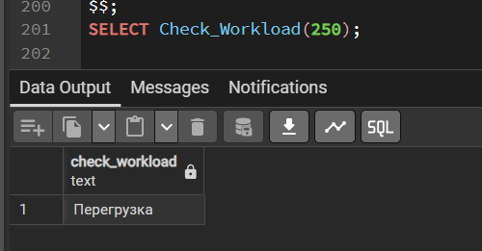
DROP TABLE IF EXISTS Workload CASCADE;
DROP TABLE IF EXISTS Combination CASCADE;
DROP TABLE IF EXISTS Study_Grpoup CASCADE;
DROP TABLE IF EXISTS WrkCrr CASCADE;
DROP TABLE IF EXISTS Bussines_Role CASCADE;
DROP TABLE IF EXISTS Student CASCADE;
DROP TABLE IF EXISTS Employee CASCADE;
DROP TABLE IF EXISTS User_Profile CASCADE;
DROP TABLE IF EXISTS Post CASCADE;
DROP TABLE IF EXISTS Department CASCADE;

CREATE TABLE Department (
ID_Department SERIAL PRIMARY KEY,
Name_Department VARCHAR(100) UNIQUE NOT NULL
);

CREATE TABLE Post (
ID_Post SERIAL PRIMARY KEY,
Name_Post VARCHAR(50) UNIQUE NOT NULL
);

CREATE TABLE User_Profile (
UP_Login VARCHAR(36) PRIMARY KEY,
UP_Password VARCHAR(36) NOT NULL,
U_Surname VARCHAR(50) NOT NULL,
U_Name VARCHAR(50) NOT NULL,
U_Patronymic VARCHAR(50) DEFAULT '-',
CHECK (CHAR_LENGTH(UP_Login) >= 8),
CHECK (
CHAR_LENGTH(UP_Password) >= 8 AND
UP_Password ~ '[A-Z]' AND
UP_Password ~ '[a-z]' AND
UP_Password ~ '[0-9]'
)
);

CREATE TABLE Employee (
Employee_Login VARCHAR(36) PRIMARY KEY,
Personal_File_N VARCHAR(16) UNIQUE,
FOREIGN KEY (Employee_Login) REFERENCES User_Profile(UP_Login) ON DELETE CASCADE,
CHECK (Personal_File_N ~ 'ЛД-[0-9]{10}')
);

CREATE TABLE Student (
Login_Student VARCHAR(36) PRIMARY KEY,
Credit_Card_N VARCHAR(16) UNIQUE,
FOREIGN KEY (Login_Student) REFERENCES User_Profile(UP_Login) ON DELETE CASCADE,
CHECK (Credit_Card_N ~ 'ЗК-[0-9]{7}-[0-9]{2}')
);

CREATE TABLE Bussines_Role (
ID_Bussines_Role SERIAL PRIMARY KEY,
Name_BR VARCHAR(50) UNIQUE,
Department_ID INT NOT NULL REFERENCES Department(ID_Department)
);

CREATE TABLE WrkCrr (
ID_WrkCrr SERIAL PRIMARY KEY,
N_Week_WrkCrr INT CHECK (N_Week_WrkCrr >= 0),
N_Hours_WrkCrr NUMERIC(5,2) CHECK (N_Hours_WrkCrr >= 0),
Bussines_Role_ID INT REFERENCES Bussines_Role(ID_Bussines_Role)
);

CREATE TABLE Study_Grpoup (
ID_Study_Grpoup SERIAL PRIMARY KEY,
Name_St_Grp VARCHAR(10) UNIQUE,
Date_Create_SG DATE NOT NULL,
WrkCrr_ID INT REFERENCES WrkCrr(ID_WrkCrr),
CHECK (Date_Create_SG >= CURRENT_DATE)
);

CREATE TABLE Combination (
ID_Combination SERIAL PRIMARY KEY,
Department_ID INT REFERENCES Department(ID_Department),
Post_ID INT REFERENCES Post(ID_Post),
Login_Employee VARCHAR(36) REFERENCES Employee(Employee_Login)
);

CREATE TABLE Workload (
ID_Workload SERIAL PRIMARY KEY,
N_Hr_Workload NUMERIC(5,1) CHECK (N_Hr_Workload >= 0),
Study_Grpoup_ID INT REFERENCES Study_Grpoup(ID_Study_Grpoup),
Combination_ID INT REFERENCES Combination(ID_Combination)
);

INSERT INTO Department (Name_Department) VALUES
('Информационные технологии'),
('Математика');

INSERT INTO Post (Name_Post) VALUES
('Преподаватель'),
('Архитектор');

INSERT INTO User_Profile VALUES
('user_ivanov', 'Password1', 'Иванов', 'Иван', '-'),
('user_petrov', 'Password1', 'Петров', 'Пётр', '-'),
('st_student1', 'Password1', 'Сидоров', 'Алексей', '-');

INSERT INTO Employee VALUES
('user_ivanov', 'ЛД-0000000001');

INSERT INTO Student VALUES
('st_student1', 'ЗК-1234567-01');

INSERT INTO Bussines_Role (Name_BR, Department_ID) VALUES
('Backend', 1),
('Frontend', 1);

INSERT INTO WrkCrr (N_Week_WrkCrr, N_Hours_WrkCrr, Bussines_Role_ID) VALUES
(16, 72, 1);

INSERT INTO Study_Grpoup (Name_St_Grp, Date_Create_SG, WrkCrr_ID) VALUES
('2Р1.22', CURRENT_DATE, 1);

INSERT INTO Combination (Department_ID, Post_ID, Login_Employee) VALUES
(1, 1, 'user_ivanov');

INSERT INTO Workload (N_Hr_Workload, Study_Grpoup_ID, Combination_ID) VALUES
(100, 1, 1);

CREATE OR REPLACE FUNCTION Department_Insert(p_name VARCHAR)
RETURNS TEXT AS $$
BEGIN
IF EXISTS (SELECT 1 FROM Department WHERE Name_Department = p_name) THEN
RETURN 'Уже существует!';
ELSE
INSERT INTO Department(Name_Department) VALUES (p_name);
RETURN 'Добавлено';
END IF;
END;
$$ LANGUAGE plpgsql;

CREATE OR REPLACE FUNCTION Department_Update(p_id INT, p_name VARCHAR)
RETURNS TEXT AS $$
BEGIN
IF EXISTS (SELECT 1 FROM Department WHERE Name_Department = p_name) THEN
RETURN 'Дубликат!';
ELSE
UPDATE Department SET Name_Department = p_name WHERE ID_Department = p_id;
RETURN 'Обновлено';
END IF;
END;
$$ LANGUAGE plpgsql;

CREATE OR REPLACE FUNCTION Bussines_Role_Delete(p_id INT)
RETURNS TEXT AS $$
DECLARE cnt INT;
BEGIN
SELECT COUNT(*) INTO cnt FROM WrkCrr WHERE Bussines_Role_ID = p_id;
IF cnt > 0 THEN
RETURN 'Нельзя удалить!';
ELSE
DELETE FROM Bussines_Role WHERE ID_Bussines_Role = p_id;
RETURN 'Удалено';
END IF;
END;
$$ LANGUAGE plpgsql;

CREATE OR REPLACE FUNCTION Check_Workload(p_hours NUMERIC)
RETURNS TEXT AS $$
BEGIN
IF p_hours > 200 THEN
RETURN 'Перегрузка';
ELSE
RETURN 'Норма';
END IF;
END;
$$ LANGUAGE plpgsql;

CREATE OR REPLACE FUNCTION Workload_Update(p_comb INT)
RETURNS NUMERIC AS $$
DECLARE total NUMERIC;
BEGIN
SELECT SUM(N_Hr_Workload) INTO total
FROM Workload WHERE Combination_ID = p_comb;
RETURN total;
END;
$$ LANGUAGE plpgsql;

SELECT Department_Insert('Физика');
SELECT Department_Insert('Информационные технологии');

SELECT Department_Update(1, 'ИТ');

SELECT Check_Workload(250);
SELECT Workload_Update(1);

DO $$
BEGIN
IF NOT EXISTS (SELECT FROM pg_roles WHERE rolname = 'rl_student') THEN
CREATE ROLE rl_student;
END IF;
IF NOT EXISTS (SELECT FROM pg_roles WHERE rolname = 'rl_teacher') THEN
CREATE ROLE rl_teacher;
END IF;
IF NOT EXISTS (SELECT FROM pg_roles WHERE rolname = 'rl_admin') THEN
CREATE ROLE rl_admin;
END IF;
END
$$;
SELECT Department_Insert('Физика');
SELECT Department_Insert('Информационные технологии');
SELECT Check_Workload(250);
SELECT Workload_Update(1);

